# ASSIGNMENT 10.1

NAME : T.Sai Tanuj

BATCH NUMBER: 15

HALLTICKET NUMBER:2403A52413

SUBJECT: AI CODING

### TASK-1

**QUESTION:**

**Task Description #1 – Syntax and Logic Errors  
Task: Use AI to identify and fix syntax and logic errors in a faulty  
Python script.  
Sample Input Code:  
# Calculate average score of a student  
def calc_average(marks):  
total = 0  
for m in marks:  
total += m  
average = total / len(marks)  
return avrage # Typo here  
marks = [85, 90, 78, 92]  
print("Average Score is ", calc_average(marks)**

**PROMPT:**

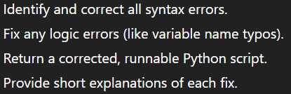

**CODE:**

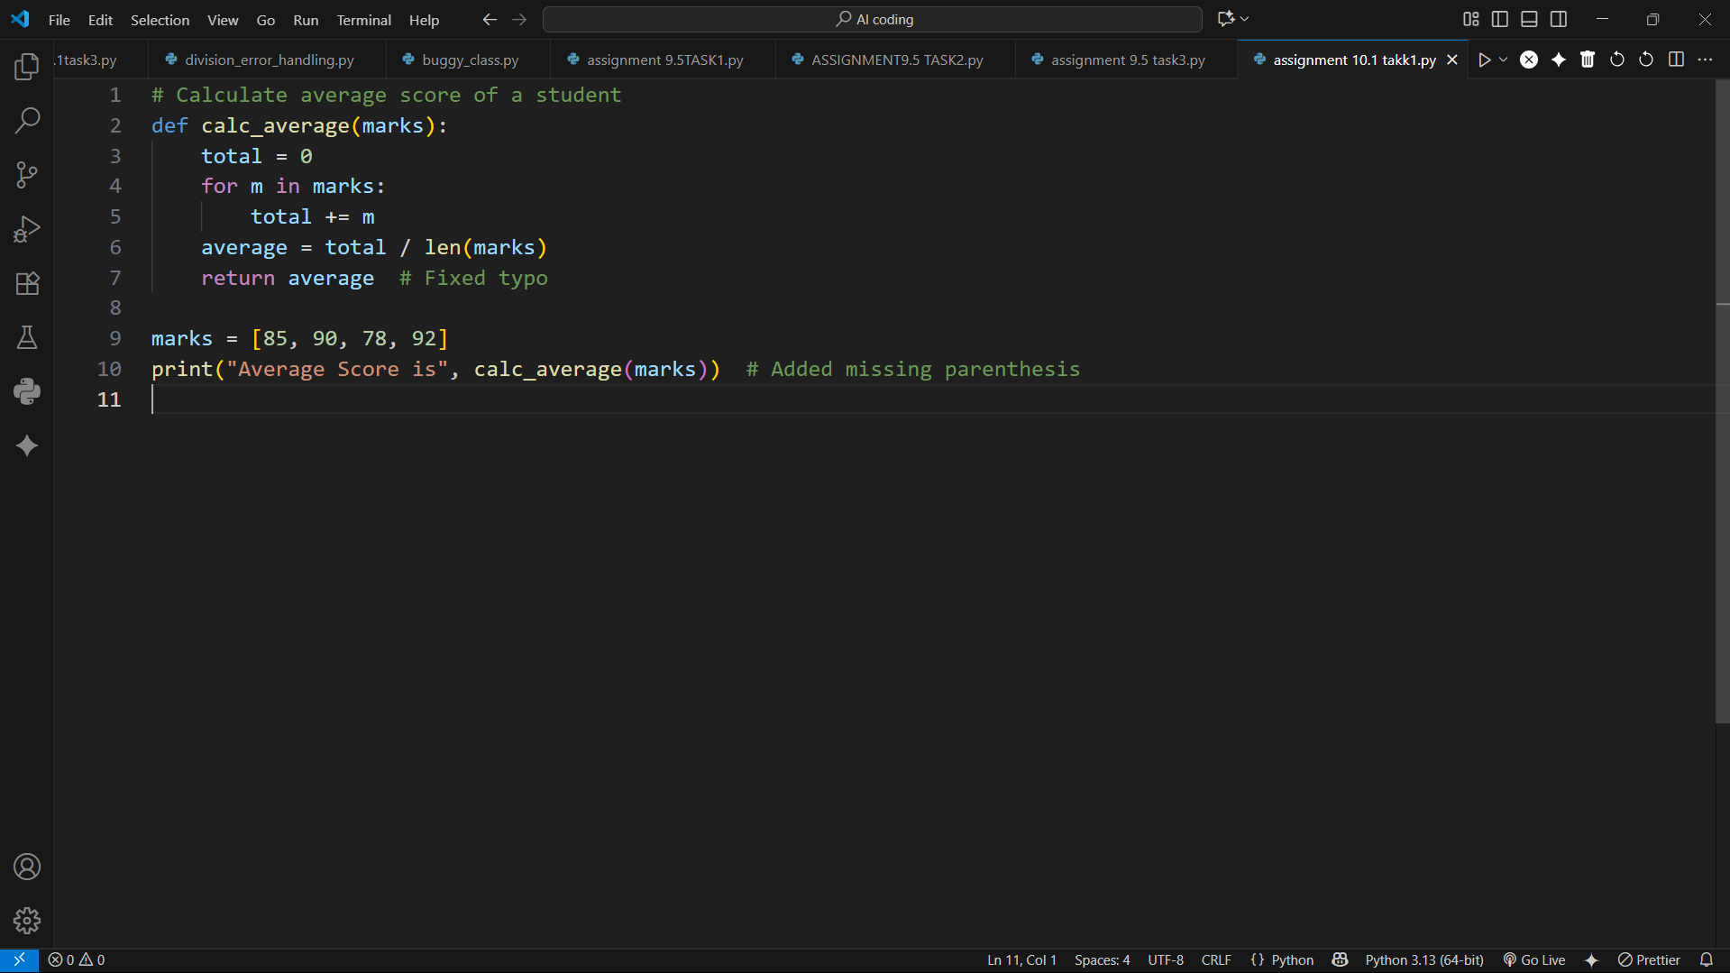

**OUTPUT:**

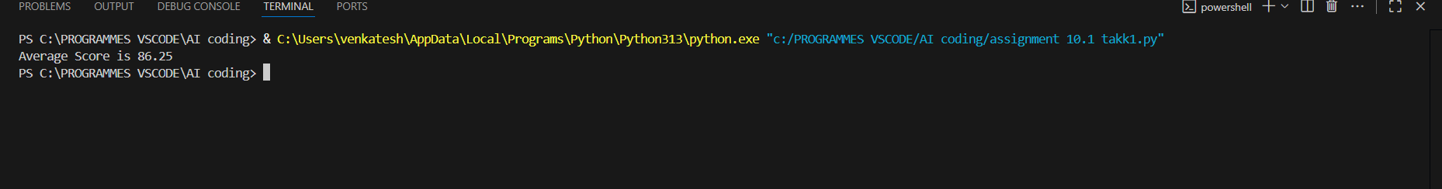

**CONCLUSION:**

The faulty Python script had issues with indentation, a typo in the return variable, and a missing parenthesis.  
After corrections, the code runs successfully and calculates the average of the given marks.  
The function now correctly returns the computed average.  
Final output displays: **Average Score is 86.25**.

### TASK-2

**QUESTION:**

**Description #2 – PEP 8 Compliance  
Task: Use AI to refactor Python code to follow PEP 8 style guidelines.  
Sample Input Code:  
def area_of_rect(L,B):return L*B  
print(area_of_rect(10,20))  
Expected Output:  
• Well-formatted PEP 8-compliant Python code**

**PROMPT:**

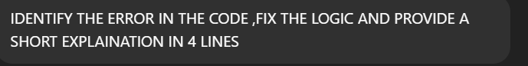

**CODE:**

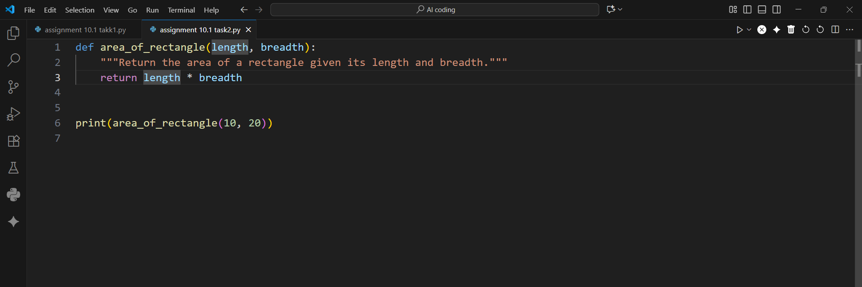

**OUTPUT:**

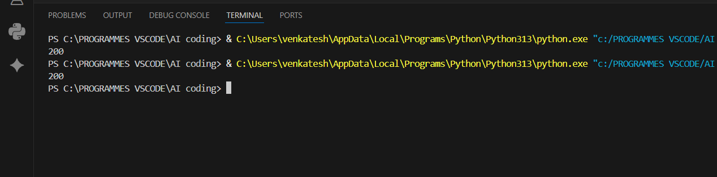

**CONCLUSION:**

The function calculates the area of a rectangle using length and breadth.  
It follows PEP 8 guidelines with proper formatting and spacing.  
Descriptive names and a docstring enhance code clarity.  
The program executes correctly and outputs **200**.

### TASK-3

**QUESTION:**

**Task Description #3 – Readability Enhancement  
Task: Use AI to make code more readable without changing its logic.  
Sample Input Code:  
def c(x,y):  
return x*y/100  
a=200  
b=15  
print(c(a,b))  
Expected Output:  
• Python code with descriptive variable names, inline comments,**

**and clear formatting**

**PROMPT:**

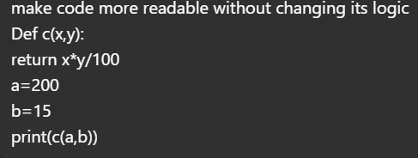

**CODE:**

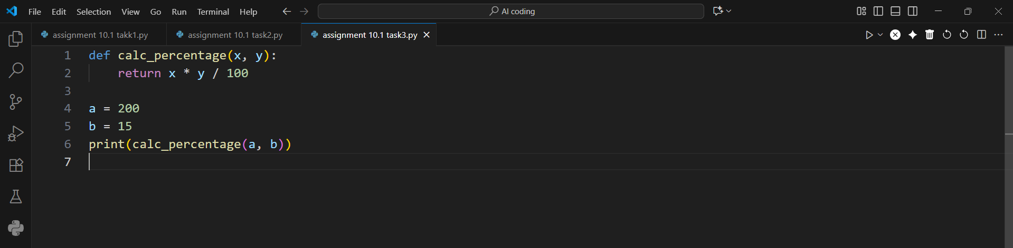

**OUTPUT:**

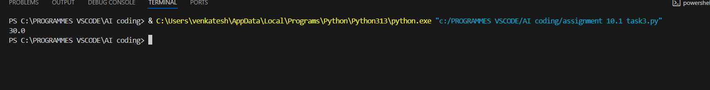

**CONCLUSION:**

The function calc_percentage multiplies two numbers and divides by 100 to calculate a percentage.  
It improves readability by using a clear function name.  
The variables a and b are passed as inputs to the function.  
The program runs successfully and outputs 30.0.

### TASK-4

**QUESTION:**

**Task Description #4 – Refactoring for Maintainability  
Task: Use AI to break repetitive or long code into reusable functions.  
Sample Input Code:  
students = ["Alice", "Bob", "Charlie"]  
print("Welcome", students[0])  
print("Welcome", students[1])  
print("Welcome", students[2])  
Expected Output:  
• Modular code with reusable functions**

**PROMPT:**

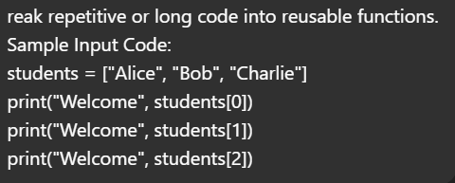

**CODE:**

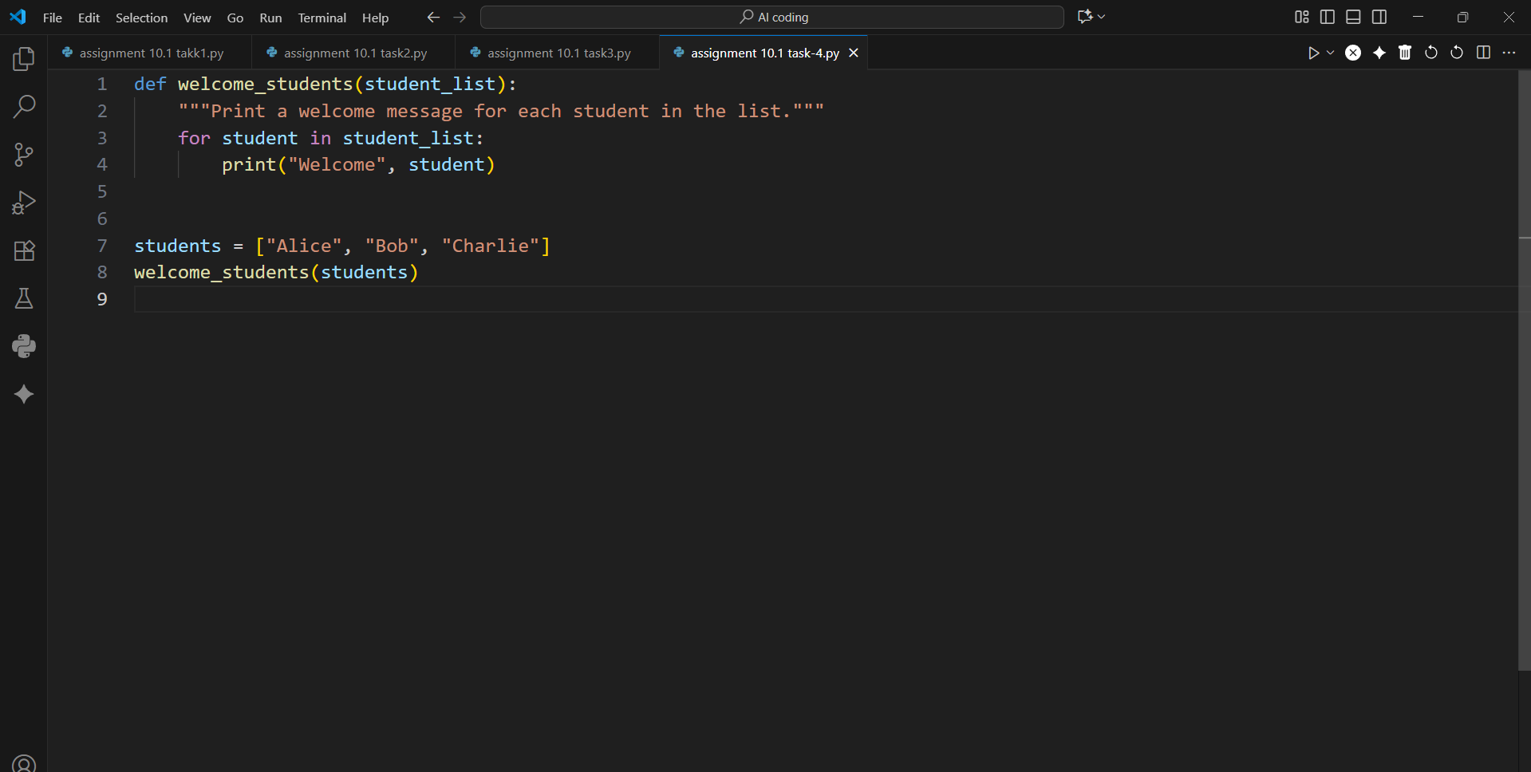

**OUTPUT:**

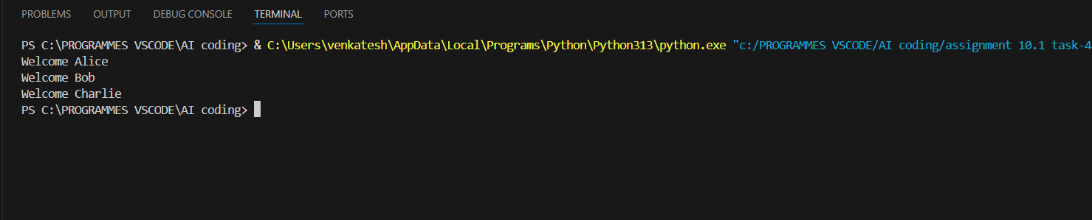

**CONCLUSION:**

The repetitive print statements are replaced with a reusable function using a loop.  
This makes the code cleaner, scalable, and easier to maintain.

### TASK-5

**QUESTION:**

**Task Description #5 – Performance Optimization  
Task: Use AI to make the code run faster.  
Sample Input Code:  
# Find squares of numbers  
nums = [i for i in range(1,1000000)]  
squares = []  
for n in nums:  
squares.append(n**2)  
print(len(squares))  
Expected Output:  
• Optimized code using list comprehensions or vectorized  
operations.**

**PROMPT:**

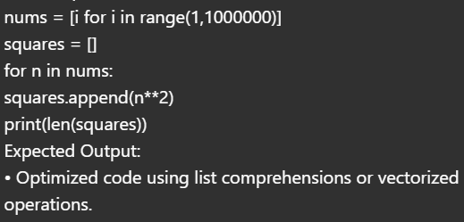

**CODE:**

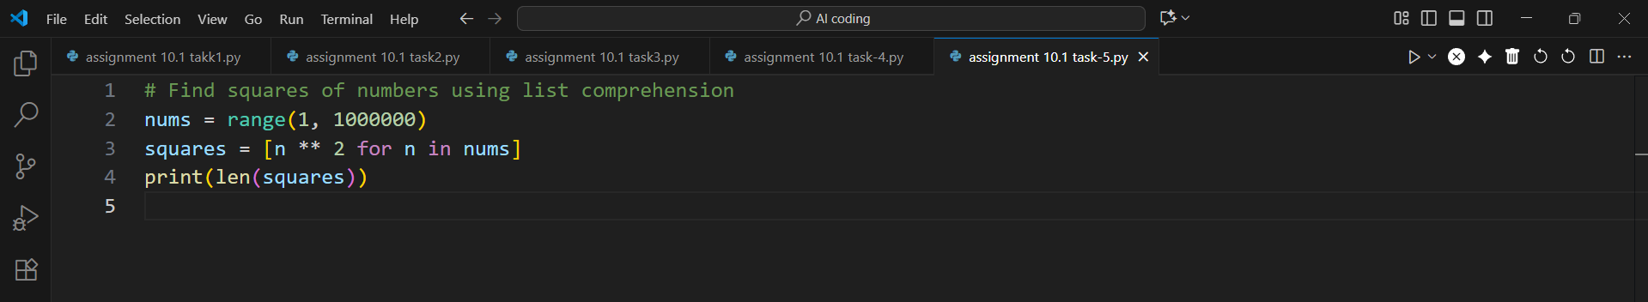

**OUTPUT:**

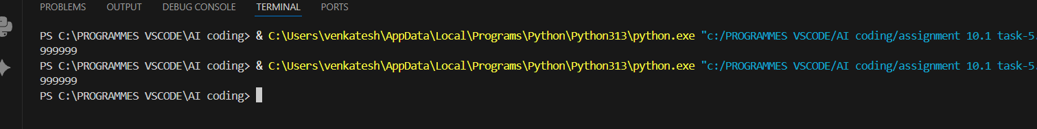

**CONCLUSION:**

The first optimized version replaces the loop with a list comprehension.  
It runs faster and uses less code while still producing the same result.

### TASK-6

**QUESTION:**

**Task Description #6 – Complexity Reduction  
Task: Use AI to simplify overly complex logic.  
Sample Input Code:  
def grade(score):  
if score >= 90:  
return "A"  
else:  
if score >= 80:  
return "B"**

**else:  
if score >= 70:  
return "C"  
else:  
if score >= 60:  
return "D"  
else:  
return "F"  
Expected Output:  
• Cleaner logic using elif or dictionary mapping**

**PROMPT:**

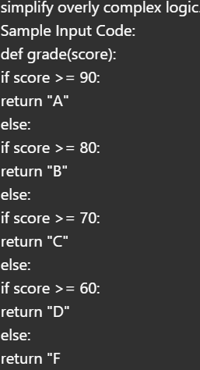

**CODE:**

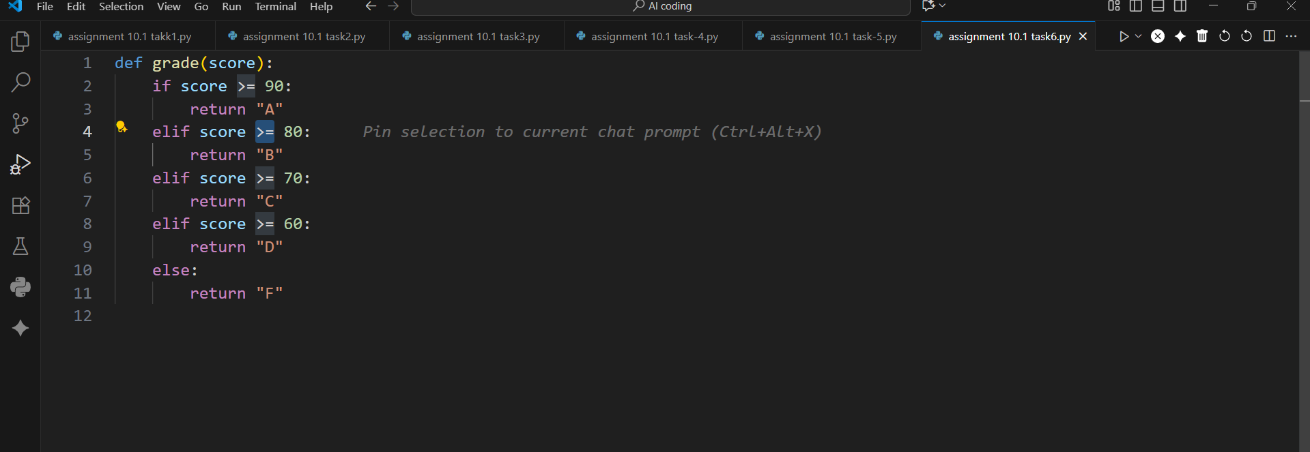

**OUTPUT:**

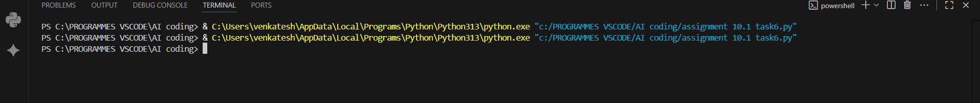

**CONCLUSION:**

The original code had deeply nested if-else statements, making it harder to read.  
It was simplified using elif, which makes the logic clearer and easier to follow.  
The function now directly checks conditions in sequence without unnecessary nesting.  
It correctly assigns grades from **A to F** based on the score.